Using this Template
The following template can be used to help your organization develop a written Machine Safeguarding Program. This template cannot be used as is – you must customize the template to meet the needs of your organization. We have made this template easier for you to customize by adding visual prompts that identify some areas where your input is needed. These are identified by yellow highlighted, red text in the template. You may also change any of the text in the template to meet your organization’s needs – for example, department names, job titles, listed responsibilities and procedures.
Example:
<Company Name>
Machine Safeguarding Program
Becomes
XYZ Company
Machine Safeguarding Program
To remove the colored highlighting from your text, left click and drag your mouse over the yellow text, clicking on the highlighter button from the font menu. To change the font color to black, select the text and click on the font color button.
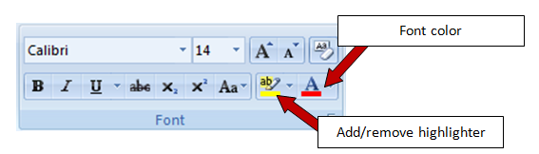

To aid you in understanding the need to customize your program, several “Check Your Understanding” text boxes are also included throughout the template. After reading the information in the text box and adding the required information into the template, you may simply right click on the cross arrow box and select “cut.”

Disclaimer. This sample safety program template cannot be used as is. You must customize the template to meet the needs of your organization. EMC does not guarantee that this template is or can be relied on for compliance with any law or regulation, assurance against preventable losses, or freedom from legal liability. We make no representations or warranties of any kind whatsoever, either express or implied, in connection with the use of this template. EMC will not be liable for your use of the template as customized by you. All safety programs and policies, including this template and the information you supply to complete it, should be reviewed by your legal counsel and/or risk management staff.

<Company Name>
Machine Safeguarding Program

Check Your Understanding. Do you need a Machine Safeguarding Program? If your organization uses machinery or equipment of any kind, the answer is likely yes. According to the National Safety Council, 15 percent of all work injuries and 20 percent of disabling work injuries involve machines. Moving machine parts have the potential to cause severe workplace injuries, such as crushed hands or fingers, amputations, burns or blindness. Safeguards are essential for protecting workers from these preventable injuries. OHSA machinery and machine guarding standard 29 CFR 1910 Subpart O identifies the minimum machine safeguarding requirements. The OHSA regulation does not require a written program; however, a written program helps organize and document inspection procedures to ensure proper safeguarding.
The control of hazardous energy (lockout/tagout), standard 29CFR 1910. 147, also applies during servicing and maintenance of machines and equipment when a safeguard is removed or bypassed or an employee is required to put a body part into the point of operation of a machine.

Revision History
<Revision XX – August 1, 2015>
Purpose and Scope
The purpose of <Company Name’s> Machine Safeguarding Program is to ensure the safety of our employees by establishing appropriate machine safeguarding procedures for any machine part, function or process that may cause injury.

This program outlines responsibilities for all <Company Name> employees, routine inspections for all machines and required employee training. All employees are required to follow the minimum procedures outlined in this program. Any deviations from this program must be immediately brought to the attention of the Program Administrator.
Program Responsibilities
Management. <Company Name> is responsible for providing equipment and resources necessary to implement this program, and for ensuring that the provisions in this program are being followed by the Program Administrator.
Program Administrator. The Program Administrator is responsible for the following:
- Ensuring each department or functional area has a copy of the program
- Ensuring that all current and new machinery is inspected for proper machine safeguarding
- Developing procedures for taking improperly guarded machines out of service
- Ensuring that improperly guarded machines are fixed before being put back into service
- Maintaining a machine-specific list of safeguarding methods
- Scheduling employee training and ensuring new hires are trained on the program
- Providing outside contractors with information on <Company Name's> machine safeguarding program
- Reviewing and updating the program and materials as needed
- Maintaining records pertaining to the program

Supervisors. Supervisors are responsible for:
- Ensuring assigned machine operators are trained on the Machine Safeguarding Program
- Stopping and correcting any unsafe work practice or condition immediately
- Notifying the Program Administrator when changes in processes increase the risk of injury or introduce a new hazard
- Conducting machine inspections to ensure there are proper safeguards
- Ensuring that employees with insufficient skills or understanding of machine safeguarding are removed and retrained before returning to machine operations
- Ensuring employees comply with all safe work practices outlined in this program

Machine Operators. Machine operators are responsible for:
- Completing all required machine safeguarding training before operating a machine
- Assisting in inspections
- Verifying guarding devices are in place and functional before using any machine
- Reporting missing or worn guards to supervisors before operating any machine
- Complying with all procedures and safe work practices outlined in this program

Machine Safeguarding Guidelines
All <Company Name> machines shall be safeguarded to prevent any part of the employee's body or clothing from making contact with a hazardous area. All points of operation, nip points, pinch points, rotating shafts and belts will be guarded. The guards will prevent objects from falling into the equipment. Safeguards must not be easily removed or altered and will be constructed of substantial material that resists fire and corrosion. When possible, <Company Name> will use clear plastic guards that allow for easy inspection.

Guards shall not create an additional hazard such as a shear point, contain a jagged edge or have unfinished surfaces. Guards shall be installed so that routine maintenance can be performed without removing the guard.

Employees shall not use any machine/equipment with a damaged or missing guard until it is repaired or replaced.

Check Your Understanding. The above outlines the minimum requirements for machine safeguarding. For additional information refer to OHSA Concepts and Techniques of Machine Safeguarding.

Machine Inspections
All new equipment and machines shall be inspected by the Program Administrator after setup and before being placed into service. All guards that came standard from the manufacturer must be in place and operational before use. Supervisors and machine operators will visually inspect their machine's safeguards before every shift.

Each machine will be thoroughly inspected monthly using the audit in Appendix A. Machines that do not pass inspection will be taken out of service. Any machine taken out of service will be isolated from its energy source(s) using the proper isolation method in the <Company Name> Lockout/Tagout Program and an out of service sign (Appendix B) will be promptly attached to the machine.

After all safeguarding issues found during the inspection are corrected to meet the standards outlined in the Machine Safeguarding List (Appendix C), the Program Administrator will authorize the area’s supervisor to put the machine back into service.

Unauthorized Removal of Machine Safeguards
Management does not tolerate the unauthorized removal of machine safeguards. Any employee found to have removed a machine safeguard without supervisor approval will be subject to <disciplinary actions up to and including termination>.

Employee Training
All employees who operate machines as part of their job will be trained on:
- Identifying the hazards associated with the machines they work with
- The written procedures for each machine they operate
- Types of safeguards and how they provide protection from hazards
- How to use the safeguard
- How and under what circumstances the safeguarding can be removed
- What to do if a safeguard is damaged, missing or is not providing adequate protection
- The types of personal protective equipment (PPE) that should be worn around their assigned machines
Retraining
Retraining will be conducted for any employee if:
- There is a change in assignment that involves using a different machine
- There is a change in the machine, equipment or processes that presents new hazards
- There is a change in the machine safeguarding procedures
- The supervisor has reason to believe or determines through inspection or observation that an employee lacks sufficient knowledge of the safeguarding procedures

All training records will be maintained in the form found in Appendix D and retained by the Program Administrator.

Periodic Program Review
The program Administrator will conduct an annual review to assess the program’s effectiveness. The review will consider any new machines, changes in processes, facility layout changes and the cost and frequency of machine-related injuries.
All machine safeguarding procedures and methods will be reviewed annually by the Program Administrator. If any inadequacies are identified, the Program Administrator will take all necessary steps to update the procedure or safeguarding method. The annual review will include a discussion between the Program Administrator and each machine operator to determine if they understand their responsibilities under the Machine Safeguarding Program. Annual reviews are documented using the form in Appendix E.
Records Retention
<Company Name> will maintain Machine Safeguarding Program training records for <3> years. All records will be kept by the Program Administrator. Inspection records and machine safeguarding lists will be retained <indefinitely>.
Check Your Understanding. There are currently no records retention requirements for the Machine Safeguarding Program. Your organization must determine the appropriate record retention period for your program.

Appendix A – Machine Safeguarding Audit

Date of Audit: | Date of Last Audit: | Audited by (list all present):
Machine Information:
Pre-Inspection Machine Notes:
Requirements For All Safeguards |  |  | Yes | No
Do the safeguards prevent workers’ hands, arms and other body parts from making contact with dangerous moving parts?
Are the safeguards firmly secured and not easily removed?
Do the safeguards ensure that no object will fall into the moving parts?
Do the safeguards permit safe, comfortable and relatively easy operation of the machine?
Can the machine be lubricated without removing the safeguard?
Is there a documented process for shutting down the machine before safeguards are removed?
Can the existing safeguards be improved?
Point of Operation Mechanical Hazards |  |  | Yes | No
Is there a point of operation safeguard provided for the machine that keeps the operator's hands, fingers and body out of the danger area?
Is there evidence that the safeguards have been tampered with or removed?
Is there a more practical or effective safeguard?
Could changes be made on the machine to eliminate the point of operation hazard?
Power Transmission Apparatus Hazards |  |  | Yes | No
Are there any unguarded gears, sprockets, pulleys or flywheels on the apparatus?
Are there any exposed belts or chain drives?
Are there any exposed setscrews, keyways, collars, etc. ?
Are starting and stopping controls within easy reach of the operator?
If there is more than one operator, are separate controls provided?
Other Moving Parts |  |  | Yes | No
Are safeguards provided for all hazardous moving parts of the machine including auxiliary parts?
Electric Hazards |  |  | Yes | No
Are there loose conduit fittings?
Is the machine properly grounded?
Is the power supply correctly fused and protected?
Do workers occasionally receive minor shocks while operating the machine?

Appendix B – Out of Service Sign
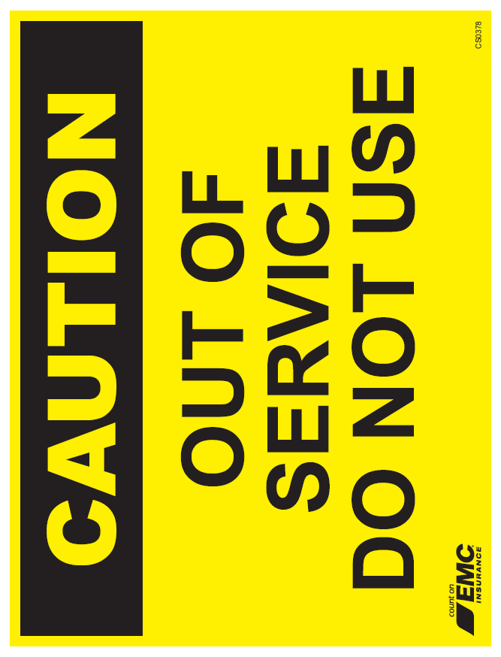

Appendix C – Machine Safeguarding List
Check Your Understanding. The safeguards required for each machine and piece of equipment should be identified and documented so that safety training and inspection criteria can be developed to keep operators safe. Most new equipment comes with appropriate guarding, but custom built and some industrial equipment does not come with complete safeguards. For additional information on machine guarding requirements and methods refer to OHSA Concepts and Techniques of Machine Safeguarding.

<Woodworking Equipment

Table Saws - All table saws will be equipped with the following:
- A self-adjusting hood guard that completely encloses the portion of the blade above the table and the portion of the blade above the material being cut
- A spreader to prevent the material from squeezing the blade and from being thrown back at the operator (spreaders are not required during grooving, dadoing or rabbeting operations)
- Non-kickback fingers/dogs to oppose the thrust or tendency of the saw blade to pick up materials or throw the material back toward the operator
Miter Saws - All miter saws will be equipped with the following:
- A hood that completely encloses the upper portion of the blade down to the point that includes the end of the arbor
- A self-adjusting lower blade guard that covers the lower portion of the blade and automatically adjusts itself to the thickness of the material being cut
Band Saws - All band saws will be equipped with the following:
- A guard enclosing all portions of the blade except for the working portion between the bottom of the guide rollers and the table
- An adjustable guard that can be raised and lowered to the thickness of the material being cut
- Fully encased band wheels
Lathes - All lathes will be equipped with a continuous guard that extends over the top of the material being worked to prevent the material from being thrown out of the machine.

Abrasive Wheels

Bench and Floor Grinders - All bench and floor grinders will be equipped with the following:
- A guard that covers the spindle end, nut and flange and allows a maximum wheel exposure of 90 degrees beginning at a point no more than 65 degrees above the horizontal surface
- An adjustable work rest that must be kept a maximum of 1/8 in from the wheel
Handheld grinders and cut-off saws - All handheld grinders and cut-off saws will be equipped with a guard that allows a maximum cutting wheel exposure of 150 degrees beginning at a point no less than 15 degrees below the horizontal surface.

Power Transmission

Shafts - All shafts will be equipped with a stationary guard that completely encloses the moving shaft and all projecting ends.

Pulleys, Gears, Chains and Belts - All pulleys, gears, chains and belts will be equipped with a stationary guard that completely encloses the moving parts.>

Appendix D – Machine Safeguarding Training Record
The following individuals received training on The Machine Safeguarding Program.

Print Name | Sign Name

Print Instructor’s Name
Instructor’s Signature
Instructor’s Title
Date of Training

Appendix E – Annual Evaluation Report
Date of Evaluation: | Evaluated By (list all present):
Written Program Reviewed: Yes/No
Comments on Written Program:
The following procedures have been reviewed:
The following procedures were modified:
The following procedures were added:
A review of the occupational injuries and illnesses log (OSHA Form 300 or equivalent) and the associated accident and illness report was made: Yes No
The following additional expense(s) resulted from improper safeguarding:
If injuries are listed above, indicate the procedure number that was not followed for the applicable equipment, process or machinery:
Comments:

