Using this Template
The following template can be used to help your organization develop a written Lockout/Tagout Program. This template cannot be used as is – you must customize the template to meet the needs of your organization. We have made this template easier for you to customize by adding visual prompts that identify some areas where your input is needed. These are identified by yellow highlighted, red text in the template. You may also change any of the text in the template to meet your organization’s needs – for example, department names, job titles and listed responsibilities and procedures.
Example:
<Company Name>
Lockout/Tagout Program
becomes
XYZ Company
Lockout/Tagout Program
To remove the colored highlighting from your text, left click and drag your mouse over the yellow text and click on the highlighter button from the font menu. To change the font color to black, select the text and click on the font color button.
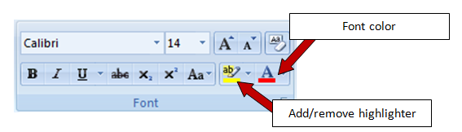

To aid you in understanding the need to customize your program, several “Check Your Understanding” text boxes are also included throughout the template. After reading the information in the text box and adding the required information into the template, you may simply right click on the cross arrow box and select “cut.”

Disclaimer. This sample safety program template cannot be used as is. You must customize the template to meet the needs of your organization. EMC does not guarantee that this template is or can be relied on for compliance with any law or regulation, assurance against preventable losses, or freedom from legal liability. We make no representations or warranties of any kind whatsoever, either express or implied, in connection with the use of this template. EMC will not be liable for your use of the template as customized by you. All safety programs and policies, including this template and the information you supply to complete it, should be reviewed by your legal counsel and/or risk management staff.

<Company Name>
Lockout/Tagout Program
(Control of Hazardous Energy)

Check Your Understanding. Do you need a lockout/tagout program? If your organization uses machinery or equipment of any kind, the answer to this question is likely “yes.” The control of hazardous energy (lockout/tagout) standard 29CFR 1910.147 applies to the control of energy during servicing and maintenance of machines and equipment. Normal production operations, with very limited exceptions, that expose an employee to dangerous moving parts are not covered by the lockout/tagout standard, but are instead addressed by the OSHA machine safeguarding standard 29 CFR 1910 Subpart O.
The lockout/tagout standard applies to your business if: (1) An employee is required to remove or bypass a guard or other safety device, or (2) an employee is required to place any part of his or her body into the “point of operation” of the machine or where an associated danger zone exists during the machine’s operating cycle.
Consider an example. Your employee needs to perform some preventative maintenance on a press in your machine shop. The employee will place his hands between the dies (in a “danger zone”) during the work. Only by shutting down the press and making sure the energy sources remain “locked out” can the employee be certain the press will not be restarted or move while he is performing the work.
If your employees are conducting work similar to the example, work as defined by the OSHA standard or work where they are endangered by other situations of uncontrolled hazardous energy, you probably need a lockout/tagout program.

Purpose
To ensure the safety of <Company Name> employees by establishing appropriate lockout/tagout (LOTO) procedures for equipment that is powered by, or capable of storing, hazardous energy.
All employees are required to follow the minimum procedures outlined in this program. Any deviations from this program must be immediately brought to the attention of the Program Administrator.
Scope
The objective of this program is to protect personnel from injury when lockout of energy is required to ensure the safety of those working in or near danger zones. Work will not begin until all forms of hazardous energy are identified and controlled to a zero hazardous energy level.
- Lockout is required if the work being done requires a person to place any part of their body into an area where a danger zone exists. Locks and/or lockout devices must be attached to the energy control point to keep the hazardous energy from being reintroduced to the equipment while work is being conducted.
- There may be multiple energy control points that affect work in a danger zone; each point must be identified and controlled.
- The lockout must provide complete energy isolation, without possible override. Note: push-buttons, selector switches, interlocks, emergency shutoffs, software controls and other control circuit type devices are not energy control points and cannot be used to fulfill this program.
- Work will not begin until all forms of hazardous energy are identified and controlled.
- All employees and contractors must have individual locks and keys such that the individual is the only person who possesses the key.
- Supervisory or foremen locks intended to protect a group of workers are not allowed. Employees working as a group must each have their own locks and utilize either a lock box or multiple user-locking devices.
- Any person entering any danger zone, regardless of length of time, must apply his or her own lock and tag to the energy-isolating devices for that danger zone.
- In situations where it is impossible to install a lock or apply a locking device, contact <an Environmental Health and Safety (EHS) Representative> for consultation and direction.
- This program does not apply to electric equipment for which electrical energy is the only energy source and it can be isolated and controlled by unplugging the equipment from the outlet and keeping the plug under the exclusive control of the employee performing the servicing or maintenance. Also, the program does not apply to installations under the exclusive control of electric utilities for the purpose of power generation, transmission and distribution.
- When the person who applied the lockout is not available to remove it, the abandoned lock procedure must be utilized. The removal of a lockout device has serious consequences and must not be taken lightly; refer to the program section Non-Routine Removal of a Lockout/Tagout Device.

Program Responsibilities
Management. <Company Name> is responsible for providing the tools and resources necessary to implement this program and for ensuring that the provisions in this program are being followed by the Program Administrator.
Program Administrator. The Program Administrator is responsible for the following:
- Developing specific lockout procedures for each individual piece of machinery/equipment at the facility. The Administrator should involve the maintenance staff, electricians, and employees operating the machinery/equipment in the development of the procedures to ensure all energy sources are identified.
- Identifying employee classifications – Authorized, Affected, and Other.
- Identifying the proper personal protective equipment (PPE) needed, if any, during the lockout/tagout procedures.
- Providing appropriate level of safety training to employees based on their classification.
- Providing outside contractors working on <Company Name> equipment with training and information on <Company Name> Lockout/Tagout Program and procedures.
- Review program at least annually, or more frequently if changes are needed or new equipment is added.
Supervisors. Supervisors are responsible for:
- Ensuring that only Authorized Employees who are qualified and trained apply and remove locks and tags.
- Ensuring that employees who are found to have insufficient skills or understanding of lockout/tagout requirements do not perform lockout/tagout and receive retraining before conducting any lockout/tagout procedures.
- Ensuring employees comply with all safe work practices described in this program.
- Providing any information necessary for the continued functioning or correction of this program to the Program Administrator.
Check Your Understanding. Three different employee classifications are outlined under the OSHA lockout/tagout standard.
Authorized Employee. A person who locks out or tags out machines or equipment in order to perform servicing or maintenance on that machine or equipment. An employee may only become an authorized employee after he or she:
- Successfully completes necessary training on lockout/tagout procedures
- Understands the purpose and function of the lockout/tagout program
- Understands and recognizes hazardous energy sources, their potential, and methods and means necessary for their control
- Demonstrates the knowledge and skill required for application, use and removal of energy control devices
Affected Employee. An employee whose job requires him/her to operate or use a machine or equipment on which servicing or maintenance is being performed under lockout or tagout, or whose job requires him/her to work in an area in which such servicing or maintenance is being performed. An example is a machine operator that does not actually perform service or maintenance on the equipment he/she typically operates.
Other Employee. Employees who are neither authorized employees nor affected employees, but are still exposed to areas where lockout/tagout is being performed. An example is an office employee who may deliver mail in the production area.

Employee Classification
Authorized Employee. An employee who is trained and who locks out or tags out a machine or piece of equipment in order to perform servicing or maintenance on that machine or piece of equipment under this program. Duties of an “Authorized” employee include:
- Completing all training required to be authorized to perform lockout/tagout on specific equipment, tool(s) or machinery under this program.
- Performing lockout/tagout activities which are in conformance with this program.
- Retaining control of the equipment, system or machinery while a lockout/tagout is in progress and works only under their own lock and tag.
- Maintaining lockout/tagout hardware and tags in good condition.

Check Your Understanding. The section below provides the basic steps that are required for a successful machine lockout. As you will note in Step 2, a machine-specific procedure must be developed for each piece of equipment in your facility. Machine-specific procedures outline the step-by-step process to be used for locking out each machine or piece of equipment. Without these, can you imagine an authorized employee trying to remember all the different energy sources and means of energy isolation for each piece of equipment in your facility? A machine-specific audit form is available in Appendix E. A sample machine-specific template is available in Appendix F and a sample completed template is included in Appendix G.

Affected and Other Employees. All employees whose job requires them to operate/use a machine or piece of equipment on which servicing or maintenance activities are being performed under lockout/tagout, or whose job requires them to be in an area in which lockout/tagout is being used, are considered “Affected” or “Other” employees. They are not authorized to implement lockout/tagout procedures.
Energy Control Procedures
Preparing equipment for lockout/tagout. The following steps are required each time lockout/tagout is performed.
Basic procedure to de-energize equipment
- The Authorized Employee should review the machine-specific lockout/tagout procedure to identify all forms of hazardous energy.
- Identify the area of work and the lockout/tagout restriction zone.
- Identify the proper control point of each source of hazardous energy.
- Obtain lock(s), tag(s), and locking and/or blocking devices.
- Notify workers of intent to de-energize—affected employees must be notified by the Authorized Employee prior to the application of any lockout or tagout device.
- Begin shutdown, de-energize and dissipate any residual energy (springs, hydraulic pressure, water pressure, steam, flywheels, gravity, etc.) by blocking, bleeding down or other appropriate means.
- Apply lockout devices to each energy source. Once the lockout device has been applied, the key shall be removed and remains exclusively in the Authorized Employee’s possession.
- Where more than one Authorized Employee will be working on a machine or piece of equipment, each Authorized Employee must apply their own lock or tag to the energy -isolation device. The key for each lock must be in the possession of the employee who applied the lock.
- Confirm the equipment has been de-energized by initiating a normal startup procedure. Ensure that no Authorized or Affected Employees are in the restricted area prior to attempting the restart of the equipment. Do not enter the machine until it is confirmed that all energy sources have been locked out. When verification is complete, return the machine to the neutral or OFF position.
- Wear the appropriate PPE.
- Begin work.
Restoring the equipment to normal operation when service is complete.
Basic procedure to remove lockout/tagout devices and reenergize the equipment
- Inspect the work area to ensure that all nonessential items, tools, etc., have been removed from the danger zone.
- Check that all the guarding and safety controls have been properly replaced.
- Notify Affected Employees and ensure that all personnel are in a safe location prior to reenergizing the equipment.
- Remove locks, tags and blocking devices.
- Reenergize the equipment/system according to the start-up procedures specific to each piece of equipment.
- Confirm the system is operating properly and safely before returning control of the equipment back to any Affected Employees.
- Remove and clean or dispose of PPE.
- Check locks, tags and lockout devices for damage or cleaning needs. Replace as needed.

Group Lockout
When a group of workers is assigned to service or repair a machine covered under the lockout program, each employee will affix a personal lock or tag to the group lockout device when he or she begins work and will only remove the device when he or she completes work on the machine.
If more than one Authorized Employee is required to lock out or tag out equipment, the following organizational procedures/structure shall be followed:
- A Primary Authorized Employee shall be designated to exercise primary responsibility for implementation and coordination of the lockout/tagout of hazardous energy sources and for the equipment to be serviced.
- The Primary Authorized Employee will coordinate with equipment operators before and after completion of servicing and maintenance operations that require lockout/tagout.
- A verification system will be implemented to ensure the hazardous energy sources have been de-energized and continue to be isolated during maintenance and servicing operations.
- Each Authorized Employee will be allowed to verify individually that the hazardous energy has been isolated and/or de-energized.
- When more than one crew, craft, department, etc., is involved, each separate group of servicing/maintenance personnel will be accounted for by a Principal Authorized Employee from each group. Note: The Principal Authorized Employee is an Authorized Employee who oversees or leads a group of servicing or maintenance workers such as plumbers or electricians. Each Principal Authorized Employee is responsible to the Primary Authorized Employee for maintaining accountability of each worker in that specific group.

Shift Changes
When work involving lockout/tagout extends beyond a single shift, the Authorized Employee going off-shift shall not remove their lock and tag until an Authorized Employee coming on-shift has placed their lock and tag on the energy-isolating device(s).
When equipment is to be taken out of service for an extended period of time, an Authorized Group Leader will also place a lock and tag on the energy-isolating device(s) until all work is completed and all other Authorized Employees’ locks and tags have been removed.
At no time should the machine being worked on be without the protection of a lockout device.

Non-Routine Removal of a Lockout/Tagout Device
When the Authorized Employee who applied the lock and any associated tags is not available to remove them, the devices may be removed by the Authorized Employee's Supervisor in accordance with the process described below:
- The Authorized Employee's Supervisor(s) must verify that any Authorized Employee who applied lock(s) and associated tag(s) is not on duty and that their work is no longer in progress. All reasonable efforts will be made to contact the Authorized Employee(s) to discuss the planned removal of their lock(s) and determine if the Authorized Employee(s) have any safety concerns with removal of their lock(s).
- An Authorized Employee/Supervisor returns the equipment to service and notifies the Affected Employees that service or maintenance is completed and the equipment is ready for use.
- When the Authorized Employee(s) whose lock(s) were removed return to work, their Supervisor(s) will again notify them that their lock(s) and tag(s) were removed.

Check Your Understanding. Employee training is a critical component of a lockout/tagout program. EMC provides several tools you can use to create or enhance your training program, including online training and safety videos.
View Lockout/Tagout Resources
Remember to document all training and retraining courses with at least the following information: employee name, trainer name, content of training and date of training. Keep all training records on file indefinitely.

Employee Training
Authorized Employees and Their Supervisors.
<Company Name> has developed and will provide lockout/tagout training on the recognition of applicable hazardous energy sources, the type and magnitude of the energy available in the workplace, the methods and means available for energy isolation and control, and removal of energy-control devices. Supervisors must supplement this general training with equipment-specific training for Authorized Employees under their direction. Equipment-specific training will be accomplished by presenting applicable written procedures to Authorized Employees, verifying that they understand the requirements of the procedure and observing correct performance of the lockout/tagout procedure(s).
Affected/Other Employees.
- Affected Employees working in areas where lockout/tagout may be used will be trained in the purpose of the lockout/tagout program, identification of locks and tags and restrictions these impose on equipment operation.
- Affected Employees must be retrained if a significant OSHA regulation or <Company Name> lockout/tagout guideline change has been made (i.e., new requirement, change in locks or tags).
- Affected Employee retraining can be delivered through awareness campaigns.
- Other Employees will be trained on the procedure and instructed never to attempt to restart or reenergize a machine that has been locked out or tagged out.
Retraining of Authorized and Affected Employees.
Retraining is required if:
- • There is a change in task assignment that involves use of different lockout/tagout procedures for which the Authorized Employee has not been previously trained.
- • There is a change in the machine, equipment or processes that presents new hazards.
- • There is a change in the energy-control procedures.
- • The Supervisor has reason to believe, or determines through a periodic inspection or observation, that an Authorized or Affected Employee is performing the energy-control procedures inadequately or has deviated from or lacks sufficient knowledge of established procedures.
Record retention.
- All training records, including employee names and training dates, will be maintained in the <Safety and Health Offices>.
- Training records will be maintained indefinitely.

Check Your Understanding. A sample authorized employee training record is provided in Appendix C. An Affected and Other Employee training record is provided in Appendix D.

Periodic Program Review
All lockout/tagout procedures will be reviewed at least annually. The procedure will be reviewed for adequacy and completeness by an Authorized Employee who does not regularly use the machine/equipment-specific lockout procedure or by a <Safety and Health Staff Member>. If any deviations or inadequacies are identified, the Program Administrator will take all necessary steps to update the procedure. The annual inspection will include a review, between the Reviewer and each Authorized Employee, of that machine/equipment to determine if they understand their responsibilities under that procedure. Annual inspections are documented with the information shown in Appendix B. This inspection record will be retained indefinitely.
Outside Contractors
Whenever outside personnel are contracted to repair machines where lockout/tagout is required, they will be informed of the energy-control procedures for each machine by the Program Administrator or an Authorized Employee. All necessary safety information will be communicated to the contractor before work commences. An Authorized Employee will assist the subcontractor in locking out the equipment per our machine-specific procedure, if needed.
Revision History
<Revision XX – November 15, 2011>

Appendix A – Definitions
Affected/Other Employee – An employee whose job requires him/her to operate or use a machine or equipment on which servicing or maintenance is being performed under lockout or tagout, or whose job requires him/her to work in an area in which such servicing or maintenance is being performed.
Authorized Employee – An employee who locks out or tags out a machine or piece of equipment in order to perform servicing or maintenance on that machine or piece of equipment.
Awareness Campaign – Communication authorized by the company for the purpose of informing employees about an issue or new policy considered to be in the interest of employee safety.
Energized – Connected to an energy source or containing residual or stored energy.
Energy-Isolating Device – A mechanical device that physically prevents the transmission or release of energy, including but not limited to the following: a manually operated electrical circuit breaker; a disconnect switch; a manually-operated switch by which the conductors of a circuit can be disconnected from all ungrounded supply conductors and, additionally, no pole can be operated independently; a line valve; a block; and any similar device used to block or isolate energy. Push buttons, selector switches and other control circuit-type devices are not energy-isolating devices.
Equipment – Includes but is not limited to machines (lathes, presses, etc.), facility mechanical systems (air handlers, elevators, utility lines, etc.), research equipment, equipment components and agricultural equipment.
Employee Supervisor – An individual administratively in charge of an authorized employee assigned to perform maintenance or service requiring the use of locks or tags.
Hazardous Energy – Electrical, mechanical, hydraulic, pneumatic, chemical, nuclear, thermal, gravitational or any other form of energy that could cause injury due to the unintended motion of energizing, start‐up, or release of such stored or residual energy in machinery, equipment, piping, pipelines or process systems.

Lockbox – A toolbox-style box of rugged construction that is capable of receiving a hasp when the box is shut. When the hasp is attached, a person cannot enter the box until the hasp is removed.
Lockout – The placement of a lockout device and tag on an energy-isolating device, in accordance with an established procedure, that ensures the energy-isolating device and the equipment being controlled cannot be operated until the lockout device is removed.
Lockout Device – A device that utilizes a positive means, such as a key-operated padlock, to hold an energy-isolating device in the safe position and prevent the energizing of a machine or equipment.
Personal Protective Equipment (PPE) – Safety equipment used by authorized employees during the lockout/tagout procedures.
Point of Operation – The area where the work actually takes place. It is the place where tools and material meet.
Program Administrator – Person responsible for researching, developing, administering and evaluating programs in response to the identified needs of the organization. Note: A Program Administrator may also be a supervisor and/or an Authorized Employee.

Service and/or Maintenance – Workplace activities such as constructing, installing, adjusting, inspecting and modifying machines or equipment. These activities include lubrication, cleaning, and unjamming of machines or equipment—as well as making adjustments or tool changes—where the employee may be exposed to the unexpected energization or start-up of the equipment or release of hazardous energy.
Setting Up – Any work performed to prepare a machine or equipment to perform its normal operation.
Tagout – The placement of a tagout device on an energy-isolating device, in accordance with an established procedure, to indicate that the energy-isolating device and the equipment being controlled may not be operated until the tagout device is removed.
Tagout device – A prominent warning device with a means of attachment, which can be securely-fastened to an energy-isolating device in accordance with an established procedure to indicate that the energy-isolating device and the equipment being controlled may not be operated until the tagout device is removed.
Testing – A determination that machinery, equipment or equipment parts are de-energized. This involves the use of properly operating test equipment designed for and capable of determining if any energized conditions exist.
Verification – Operation of equipment controls for the purpose of determining that equipment cannot be restarted after an energy-isolating procedure has been performed and before maintenance or repair work is initiated.

Appendix B – Annual Evaluation Report
Date of Evaluation: | Evaluated By (list all present):
Written Program Reviewed: Yes No
Comments on Written Program:
The following specific procedures have been reviewed:
The following specific procedures were modified:
The following specific procedures were added:
A review of the log of occupational injuries and illnesses (OSHA Form 300 or equivalent) and the associated accident reports and injury and illness reports were made: Yes No
The following injuries resulted from failure to use correct lockout/tagout procedures:
If injuries are listed above, indicate procedure number for applicable equipment, process, or machinery:
Comments:
Appendix C – Authorized Employee Training Record
This is to certify that the undersigned received training in accordance with 29 CFR 1910.147(c)(7) and the provisions of <Company Name> Lockout/Tagout Program.

Print Name | Sign Name

Print Instructor’s Name
Instructor’s Signature
Instructor’s Title
Date of Training

Appendix D – Affected/Other Employee Training Record
This is to certify that the undersigned received training in accordance with 29 CFR 1910.147(c)(7) and the provisions of <Company Name> Lockout/Tagout Program.

Print Name | Sign Name

Print Instructor’s Name
Instructor’s Signature
Instructor’s Title
Date of Training

Appendix E – Machine-Specific Energy Identification Form
Equipment:
Location:
Surveyed by:
Date of Survey:
Energy Source Present | Magnitude of Energy | Method to Isolate  Energy Source | Verification Procedure
Electrical
Pneumatic
Hydraulics
Water under pressure
Gas under pressure
Steam under pressure
Gravity
Thermal (heat)
Chemical
Mechanical
Other:
Other:
Notes:

Appendix F – Machine-Specific Lockout Procedure
Machine Utilizing This Procedure: <Machine Name>

Purpose
This procedure establishes the minimum requirements for the lock out of energy-isolating devices whenever maintenance or servicing is done on this machine or equipment. It shall be used to ensure that this machine or equipment is stopped, isolated from all potentially hazardous energy sources and locked out before employees perform any servicing or maintenance where the unexpected energization or start-up of the machine or equipment or release of stored energy could cause injury.

Compliance with This Program
All employees are required to comply with the restrictions and limitations imposed upon them during the use of lockout. The Authorized Employees are required to perform the lockout in accordance with this procedure. All employees, upon observing a machine or piece of equipment which is locked out to perform servicing or maintenance, shall not attempt to start, energize or use that machine or equipment. Failure to comply with this program will result in disciplinary action as outlined in the employee policy.

Photos: Optional but Desirable

Procedure for Controlling Hazardous Energy
- Notify Affected Employees that may also work on or near the machine that the machine is about to be shut down and locked out.
- Be familiar with the sources of hazardous energy for the machine or equipment that will be serviced.
  - <Energy Source and Magnitude>
  - <Energy Source and Magnitude>
- Shut down the machine using the normal stopping procedure.
- Isolate all energy sources listed above.
  - <Isolation procedure>
  - <Isolation procedure>
- Verify that the machine is locked out by pressing the START button. No power should be present. Return control to OFF position.
- The machine is now locked out and work may begin.

Procedure for Placing Machine Back in Service
- Check the machine to make sure it is operationally intact, tools have been removed, and guards have been replaced.
- Check to be sure that all employees are safely positioned.
- Verify that the controls are in neutral.
- Remove the lockout devices and blocking and reenergize the machine or equipment.
- Restore energy to the machine.
- Notify all other Affected Employees that the machine is ready for operations.

Appendix G – Example of Completed Machine-Specific Lockout Procedure
Machine Utilizing This Procedure: Blowmatic

Purpose
This procedure establishes the minimum requirements for the lock out of energy-isolating devices whenever maintenance or servicing is done on this machine or equipment. It shall be used to ensure that this machine or equipment is stopped, isolated from all potentially hazardous energy sources and locked out before employees perform any servicing or maintenance where the unexpected energization or start-up of the machine or equipment or release of stored energy could cause injury.

Compliance with This Program
All employees are required to comply with the restrictions and limitations imposed upon them during the use of lockout. The Authorized Employees are required to perform the lockout in accordance with this procedure. All employees, upon observing a machine or piece of equipment which is locked out to perform servicing or maintenance, shall not attempt to start, energize or use that machine or equipment. Failure to comply with this program will result in disciplinary action as outlined in the employee policy.
Elec
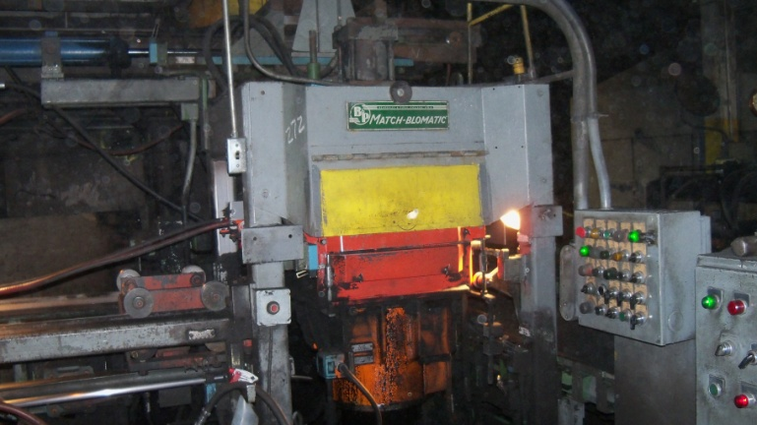
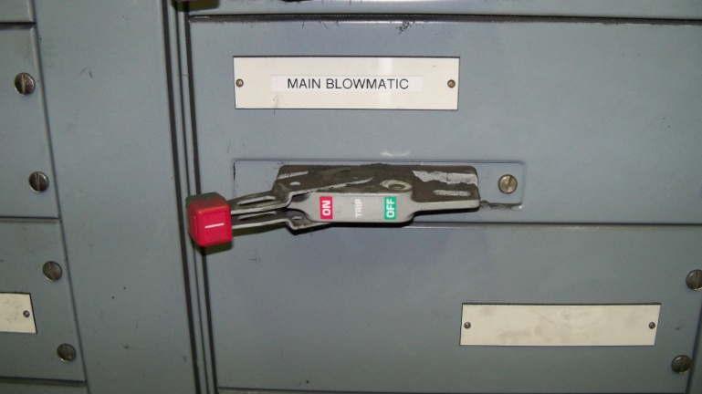
Air | Hyd

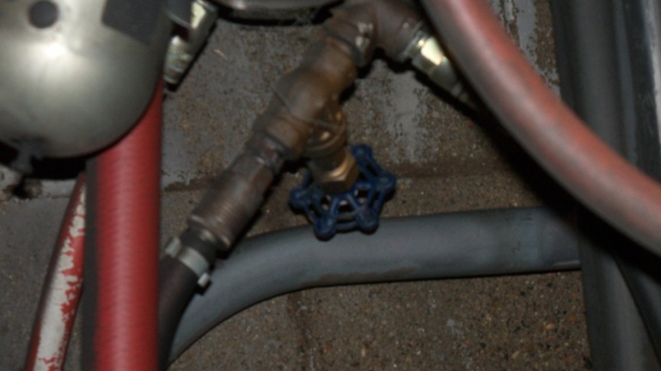
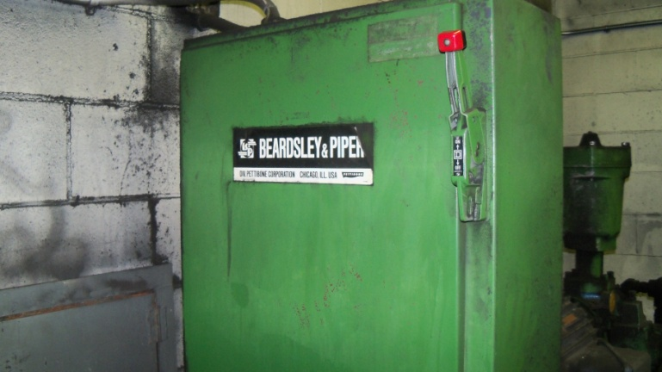

Procedure for Controlling Hazardous Energy
- Notify Affected Employees that may also work on or near the machine that the machine is about to be shut down and locked out.
- Be familiar with the sources of hazardous energy for the machine or equipment that will be serviced.
  - Electrical – 480 volts
  - Air – 100 psi
  - Hydraulic – 650 psi max, powered by 480 volt motor
- Shut down the machine using the normal stopping procedure.
- Isolate all energy sources listed above.
  - Electrical – Move wall disconnect to OFF position. Apply lock to switch.
  - Air – Apply cover over gate valve. Apply lock. Bleed off any stored air pressure.
  - Hydraulic – Move electrical disconnect to OFF position. Apply lock to switch. Bleed off any stored hydraulic pressure.
- Verify that the machine is locked out by pressing the START button. No power should be present. Return control to OFF position.
- The machine is now locked out and work may begin.

Procedure for Placing Machine Back in Service
- Check the machine to make sure it is operationally intact, tools have been removed and guards have been replaced.
- Check to be sure that all employees are safely positioned.
- Verify that the controls are in neutral.
- Remove the lockout devices and reenergize the machine or equipment.
- Restore energy to the machine.
- Notify all other Affected Employees that the machine is ready for operations.

