Using this Template
The following template can be used to help your organization develop a written Fleet Safety Program. This template cannot be used as is – you must customize the template to meet the needs of your organization. We have made this template easier for you to customize by adding visual prompts that identify some areas where your input is needed. These are identified by yellow highlighted, red text in the template. You may also change any of the text in the template to meet your organization’s needs – for example, department names, job titles and listed responsibilities and procedures.
Example:
<COMPANY NAME>
Fleet Safety Program
becomes:
XYZ Company
Fleet Safety Program
To remove the colored highlighting from your text, left click and drag your mouse over the yellow text and click on the highlighter button from the font menu. To change the font color to black, select the text and click on the font color button.
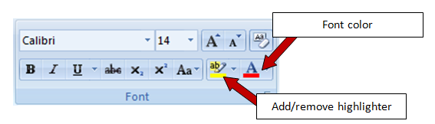

To aid you in understanding the need to customize your program, several “Check Your Understanding” text boxes are also included throughout the template. After reading the information in the text box and adding the required information into the template, you may simply right click on the cross arrow box and select “cut.”

Disclaimer. This sample safety program template cannot be used as is. You must customize the template to meet the needs of your organization. EMC does not guarantee that this template is or can be relied on for compliance with any law or regulation, assurance against preventable losses, or freedom from legal liability. We make no representations or warranties of any kind whatsoever, either express or implied, in connection with the use of this template. EMC will not be liable for your use of the template as customized by you. All safety programs and policies, including this template and the information you supply to complete it, should be reviewed by your legal counsel and/or risk management staff.

<COMPANY NAME>
Fleet Safety Program (Non-DOT)

Check Your Understanding. Many organizations use vehicles to conduct their daily business. Whether you operate a delivery company where driving is a major part of your daily activities, or you are a contractor where vehicles are used only to transport tools and employees to work sites, it is critical that a fleet safety program is included in your overall safety program. A comprehensive fleet safety program not only reduces the risk of injuries and fatalities to your employees and the rest of the driving public, but also provides the following additional potential benefits:
- Improved driver safety and morale
- Reduced property damage
- Reduced accident frequency and associated vehicle repair costs
- Increased resale value of vehicles
- Improved community safety
- Reduced driver downtime, sick pay and turnover
- Enhanced overall organizational image
For additional information regarding the development of a fleet safety program, click here: Fleet Safety LPIM.

Purpose
The operation of motor vehicles is a necessary part of <Company Name> business. The operation of motor vehicles exposes our company to the risk of loss – through injury to employees or the general public, damage to property and to our company’s overall reputation. Therefore, as a part of management’s commitment to operate all aspects of the business in a safe and responsible manner, we have created the following Fleet Safety Program.
The purpose of this Fleet Safety Program is to detail the policies and procedures <Company Name> takes to minimize the frequency and severity of vehicle accidents. All employees are required to follow the procedures outlined in this program. Any deviations from this program must be immediately brought to the attention of the Fleet Safety Program Administrator.
Scope
This policy applies to all drivers of company-owned, leased, rented or borrowed vehicle and all drivers of non-owned company vehicles while being operated on company business regardless of the amount of time spent in the vehicle.
The Fleet Safety Program Administrator is responsible for the program’s implementation, management and recordkeeping requirements.

Program Responsibilities
Management. The management of <Company Name> is committed to the Fleet Safety Program. Management supports the efforts of the Fleet Safety Program Administrator by pledging financial and leadership support towards the identification and control of hazards related to motor vehicle operation.
Fleet Safety Program Administrator. The Program Administrator reports directly to upper management and is responsible for this program. All driver selection, vehicle maintenance, training and other program components will be coordinated under the direction of the Program Administrator in collaboration with management. The Program Administrator monitors the results of the program to determine needed modifications or additional areas of focus. The Program Administrator also performs the following duties:
- Evaluates applicants to determine if they are eligible to drive our vehicles or other vehicles on company business
- Authorizes those persons who are allowed to operate vehicles
- Ensures vehicles are maintained in safe condition
- Develops and enforces fleet safety rules and policies
- Investigates all vehicle accidents and recommends any necessary corrective actions
- Coordinates driver training programs
- Annually reviews this written program and makes any changes needed. Documents the annual review on the proper forms (found in Appendix A) and submits the report to upper management
Employees. Every employee of <Company Name> is responsible for conducting himself/herself in accordance with this program. Employee involvement is an essential element to the success of our fleet safety efforts. Employees may be solicited for their input regarding vehicle selection, safety features, training programs and other topics related to this program.
Driver Selection
<Company Name> will check the driving history of all applicants through the use of a Motor Vehicle Record (MVR) before they are granted driving privileges and obtain an updated MVR for all approved drivers annually thereafter. MVRs will also be checked whenever an employee is involved in a motor vehicle accident. A driver list is maintained and updated annually, including the last date of an MVR for each driver. The approved drivers' list will be recorded on the proper form found in Appendix B and maintained by the Program Administrator.
Employees will be prohibited from operating vehicles on company business under any of the following conditions:
- Employees under 25 years of age
- Employee does not have a valid driver’s license, or the license has been suspended or revoked
- Employee does not have at least one year of verifiable driving experience. <Delete if not applicable> If the cargo includes large volumes of hazardous materials (i.e., petroleum or chemical tankers), at least five years experience is required
- Employee’s MVR indicates more than two at-fault accidents, or three moving violations, or two moving violations plus one at-fault accident in the past three years
- Employee’s MVR indicates any one of the following major violations within the past five years:
- Driving under the influence
- Reckless driving/speed contests
- Hit and run
- Vehicular manslaughter/homicide
- Leaving the scene of an accident
- Fleeing/eluding a police officer
- Passing a stopped school bus
- Speeding 15 or more miles over the speed limit
- Refusing a chemical test
- Operating with a suspended or revoked license
- Employee has tested positive in an alcohol or drug test while in our employment
- <enter any additional driver selection criteria used by your organization>

Authorized Vehicle Use
The Program Administrator determines who is authorized to operate vehicles on company business. No employee or nonemployee (for example, an employee’s spouse or child) is allowed to operate a company vehicle, or their own vehicle on company business, unless the Program Administrator has authorized that person to drive. Before any nonemployee is permitted to use a company vehicle, he or she must meet the same qualifications as those for employees. Use of company vehicles by employees and nonemployees under the age of 18 is prohibited.
Vehicle Maintenance
To extend the useful life of vehicles, regular inspections and maintenance will be completed on all company owned and operated vehicles per the manufacturer’s recommendations. If during an inspection any of the items are found “not okay,” the vehicle will be removed from service until it can be repaired or replaced. All problems must be promptly reported to the Program Administrator. Each driver will inspect the vehicle before each use. The inspection will consist of all items listed in the Vehicle Self-Inspection Report (form located in Appendix C). All vehicle Self-Inspection Reports will be submitted to the Program Administrator within one business day.
In states that require emissions testing, all vehicles will comply with the state’s requirements.
Driver Safety Rules
All motor vehicle operators must obey all state laws and posted signs when operating vehicles. In addition, the following rules must be followed at all times.
Cell Phones and Other Distractions. The use of handheld or hands-free cell phones, or other devices that take attention away from the driving task, are prohibited when driving company vehicles. Passengers may use devices only if the use will not be distracting to the driver. Cell phone calls should be made prior to or at the completion of a trip. If a call must be made during a trip, drivers must pull into a safe location and stop before making the call. If the driver receives an incoming call while driving, they must allow the call to go to voicemail and return the call when stopped in a safe location. Eating while driving is prohibited. Nonalcoholic drinks may be consumed with great discretion and only in situations where driving hazards are minimal (i.e., not in traffic, through road construction, etc.)
Seat Belts. Seat belts must be properly worn by all drivers and passengers while the vehicle is in operation. Children being transported in a company vehicle must remain properly secured in a child safety seat or booster seat according to state law.
Drugs and Alcohol. Drivers will not operate a motor vehicle at any time when his/her ability is impaired, affected or influenced by alcohol, illegal drugs, medication, illness, fatigue or injury. The sale, purchase, transfer or possession of any controlled substance (except medically prescribed drugs) is strictly prohibited while using a company vehicle, while on the company premises or while engaged in company business.
Severe Weather. Extreme caution must be exercised when driving in severe weather conditions. If a driver has any doubt about the safety of travel, they must contact their supervisor or the Program Administrator for guidance.
Radar Detectors. The use of radar detectors or any other device with the purpose of detecting or interfering with police radar is prohibited.
Glass. Damaged glass should be reported immediately to the Program Administrator. To reduce windshield damage, drivers will:
- Keep a safe distance between vehicles, especially on gravel roads
- Use clean, greaseless, dry cloths to wipe the windshield
- Replace worn wiper blades as soon as they begin to streak
- Use plastic or rubber ice scrapers, never metal
Towing. Only vehicles specifically approved for towing by the Program Administrator may be used to tow trailers of any size or type.
<Enter any additional driver safety rules used by your organization>
Traffic Violations and Citations
Drivers are responsible for all citations received. Traffic citations must be reported to the Program Administrator as soon as possible. The Program Administrator will review the driving privileges of any employee charged with a serious offense. Disciplinary action may include warnings, probation or suspension of driving privileges. For those jobs that require operation of a company vehicle, loss of driving privileges may result in termination.
Vehicle Accident Investigation. Vehicle accident investigations are handled internally and may utilize external documents such as police reports. Vehicle accident reports are to be filled out by the driver and returned to the Program Administrator as soon as reasonably possible. The Program Administrator will determine accident preventability and the proper course of disciplinary action that might be necessary. The Program Administrator will also determine if additional training is needed to prevent similar accidents from occurring in the future. Trends in types of accidents or multiple accidents by the same driver will receive additional scrutiny, as they may signal the need for additional training or changes to driver selection procedures.
When in an accident, drivers must:
- Stop your vehicle and protect the scene to prevent a secondary accident.
- Call for medical assistance and assist any injured people, if necessary.
- Call the police and the Program Administrator or supervisor as soon as possible.
- Locate any witnesses and get important information from them. If possible, get names, addresses and phone numbers.
- Exchange pertinent information with other drivers.
- Take photos of the accident.
- Fill out a vehicle accident report form and send it to the Program Administrator (forms are in Appendix D).
- Never admit fault or apologize. Apologies could be interpreted as an admission of fault.
- Never argue with other drivers or witnesses.
- Never argue with the police.
- Never make a statement to the media. Refer them to the Program Administrator.
- Never discuss details of the incident with anyone except a representative of <Company Name> or the police.
- Report every accident no matter how small to the Program Administrator.
Vehicle Accident Report forms must be kept in each company vehicle for use after an accident. If the vehicle you are driving does not have a Vehicle Accident Report form in it, contact the Program Administrator.

Check Your Understanding. Did you know that EMC provides free vehicle accident report forms on the Loss Control section of their website? www.emcins.com
Click the links below:
Accident Report Forms
Accident Report Forms California

Driver Training. Upon initial assignment of driving privileges, each driver will be required to attend a training session that outlines the rules and procedures in our Fleet Safety Program. Ongoing training will be offered to all drivers, at least annually, to ensure they are kept up-to-date with defensive driving techniques and changes to the policies and program. Driver ride-a-longs may also be conducted upon initial hire and periodically thereafter as deemed appropriate by the Program Administrator. Training and retraining will be documented by the Program Administrator (Training Record/Certification forms are in Appendix E).

Check Your Understanding. Did you know that EMC provides many free website-based services to assist you in your driver training efforts? Here are just a few examples:
- Safety Talks. These one-page handouts can be used for your next safety meeting, as a payroll stuffer or as a posting on a bulletin board. We have several hundred on driver safety and more than a thousand on additional safety topics.
- Online Training. Train your employees when it’s convenient for you with these self-directed online programs. Two programs are available: Defensive Driving and Backing and Parking. You can also register for the Training Management System, which tracks your organization’s training records.
- Safety Videos. Hundreds of streaming safety videos are available to watch instantly, or you can request a DVD.
- Safety Signs and Posters. Order driver safety signs and posters from our website or download them as high-resolution PDFs for immediate printing.
Need something more specific? Contact us at losscontrol@emcins.com and one of our Risk Improvement Representatives will contact you with further information.

Periodic Program Review
At least annually, the Program Administrator will conduct a program review to assess the progress and success of the Fleet Safety Program. The review will consider the following:
- Evaluation of all training programs and records
- The frequency and severity of vehicle accidents during the previous year
- The need for changes to the Fleet Safety Program, based on evaluation of the program and results
- The need for changes to the driver selection/disqualification criteria
Record Retention
All records will be retained for XX years.
Revision History
<Revision XX – March 2012>

Appendix A – Annual Evaluation Report
Date of Evaluation: | Evaluated by (list all present):
Written Program Reviewed: Yes No
Comments on Written Program:
Do vehicle accident records indicate a need for additional employee training on the program? Yes No
The following content was added/modified/removed from the written program:

Comments:

Appendix B – Driver List
Those listed below have been authorized to operate motor vehicles on company business and have received instruction regarding the <Company Name> Fleet Safety Program.

Employee Name | Date of Last MVR Check

Appendix C – Vehicle Self-Inspection Report
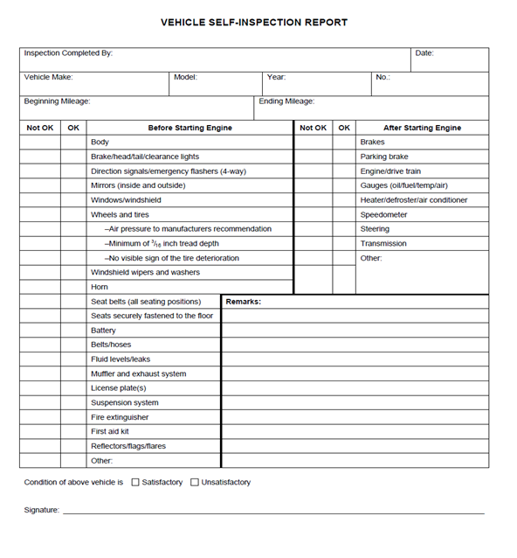

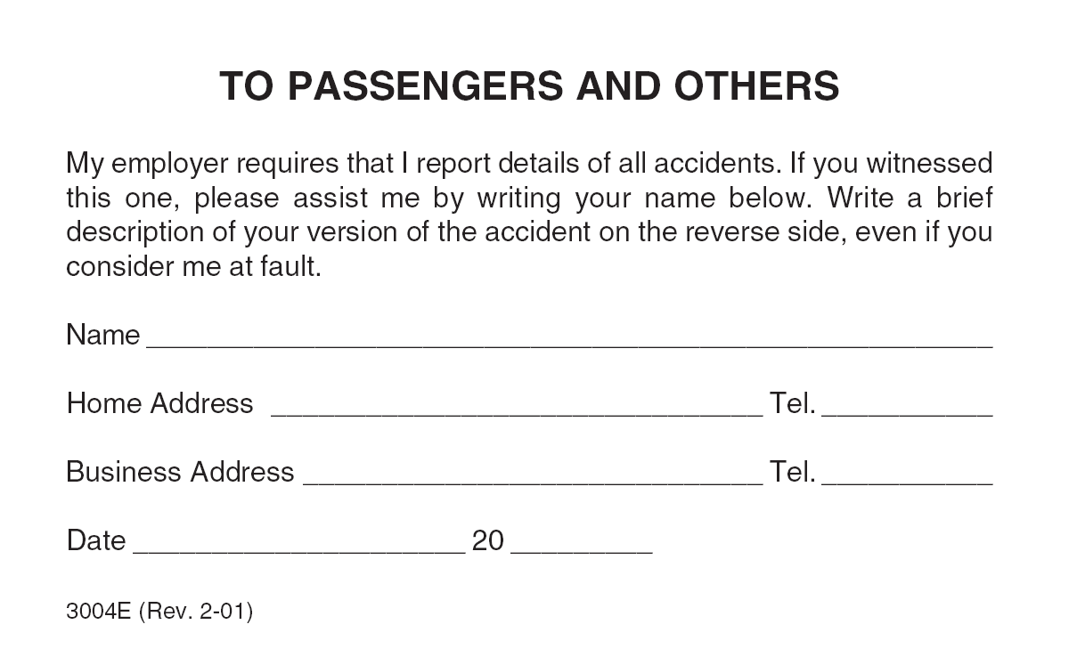
Appendix D – Vehicle Accident Report
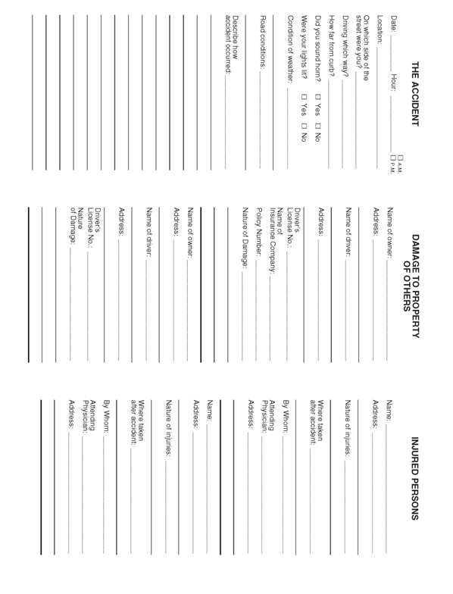

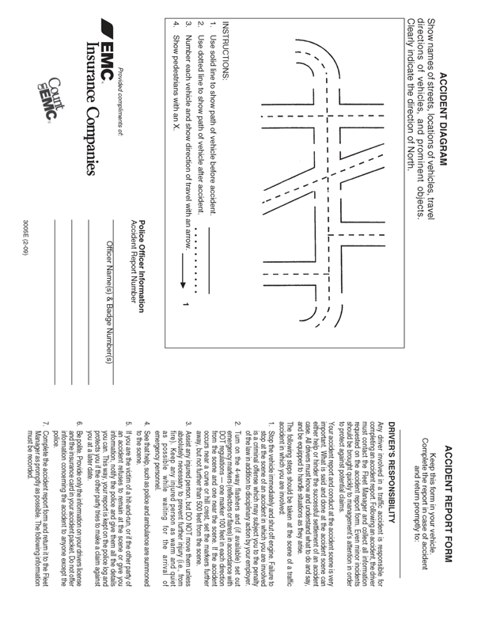

Appendix E – Training Record/Certification for Fleet Safety Program
This is to certify that the undersigned received training in accordance with the <Company Name>Fleet Safety Program.
Print Name | Sign Name

Print Instructor’s Name
Instructor's Signature
Instructor’s Title
Date of Training

